Emanuel de Oliveira Costa

Nautic.Bot: A water turbine for maritime tracking that offers real-time telemetry for companies and has potential for recreational use.

SÃO PAULO
2025

Emanuel de Oliveira Costa

Nautic.Bot

Final Course Project submitted to the Institute of Technology and Leadership (INTELI), to obtain a bachelor's degree in Software Engineering. Advisor: Prof. Hermano Peixoto de Oliveira Junior.

SÃO PAULO
2025

Cataloging in Publication
Library and Documentation Service
Institute of Technology and Leadership (INTELLI)
Data entered by the author.



Resumo (mandatory item – NBR 14724, item 4.2.1.7)

OLIVEIRA COSTA, Emanuel. Nautic.Bot. 2025. nº de folhas. TCC (Graduação) – Curso Engenharia de Software, Instituto de Tecnologia e Liderança, São Paulo, 2025.

Este trabalho apresenta o desenvolvimento da Nautic.Bot, uma turbina subaquática compacta controlada remotamente para apoio a segurança e uso recreativo em ambientes marítimos, composta por um transmissor portátil e um receptor embarcado na turbina. O objetivo central foi criar um sistema de controle sem fio robusto, com baixa latência e mecanismos de segurança, capaz de acionar motores brushless via ESC. A abordagem integrou arquitetura eletrônica com ESP32-C3 Super Mini, rádios NRF24L01, reguladores MT3608 e LM2596, diodo de proteção e alimentação combinada (9V e LiPo), além de firmware em C++. No transmissor, leituras analógicas de joysticks e estados de botões são organizados em pacotes compactos. No receptor, o firmware desativa Wi-Fi/Bluetooth para reduzir interferências, valida integridade por CRC32, executa callbacks de botões/joysticks e converte comandos em PWM de 1000–2000 µs para o ESC. Os resultados evidenciam integração estável entre controle e turbina, transmissão confiável e resposta contínua, estabelecendo a viabilidade técnica do produto. Conclui-se que a solução atende aos requisitos de controle remoto responsivo e seguro, abrindo caminho para evoluções em desempenho, autonomia energética e ergonomia do controlador.

Palavras-chave: turbina subaquática; controle remoto; comunicação sem fio; ESP32-C3; NRF24L01.

ABSTRACT (mandatory item – NBR 14724, item 4.2.1.8)

Oliveira Costa, Emanuel. Nautic.Bot. 2025. nº de folhas. TCC (Graduação) – Curso Engenharia de Software, Instituto de Tecnologia e Liderança, São Paulo, 2025.] (The reference is an optional item. NBR 6028, item 4.1.6)

This work presents the development of a compact, remotely controlled underwater turbine for safety and recreational use in marine environments. It consists of a portable transmitter and a receiver mounted on a buoy/turbine. The central objective was to create a robust wireless control system with low latency and safety mechanisms, capable of driving a brushless motor via ESC. The approach integrated an electronic architecture with ESP32-C3 Super Mini, NRF24L01 radios, MT3608 and LM2596 regulators, a protection diode, and a combined power supply (9V and LiPo), as well as firmware in C++/Arduino. In the transmitter, analog readings from joysticks and button states are organized into compact packets. In the receiver, the firmware disables Wi-Fi/Bluetooth to reduce interference, validates integrity using CRC32, executes button/joystick callbacks, and converts commands into 1000–2000 µs PWM for ESCs, applying calibration. The results demonstrate stable integration between the control and turbine, reliable transmission, and continuous response, establishing the product's technical viability. It is concluded that the solution meets the requirements for responsive and safe remote control, paving the way for advancements in performance, energy autonomy, and controller ergonomics.
.

Keywords : underwater turbine; remote control; wireless communication; ESP32-C3; NRF24L01.

List of Illustrations
Figure 1 – Control Architecture
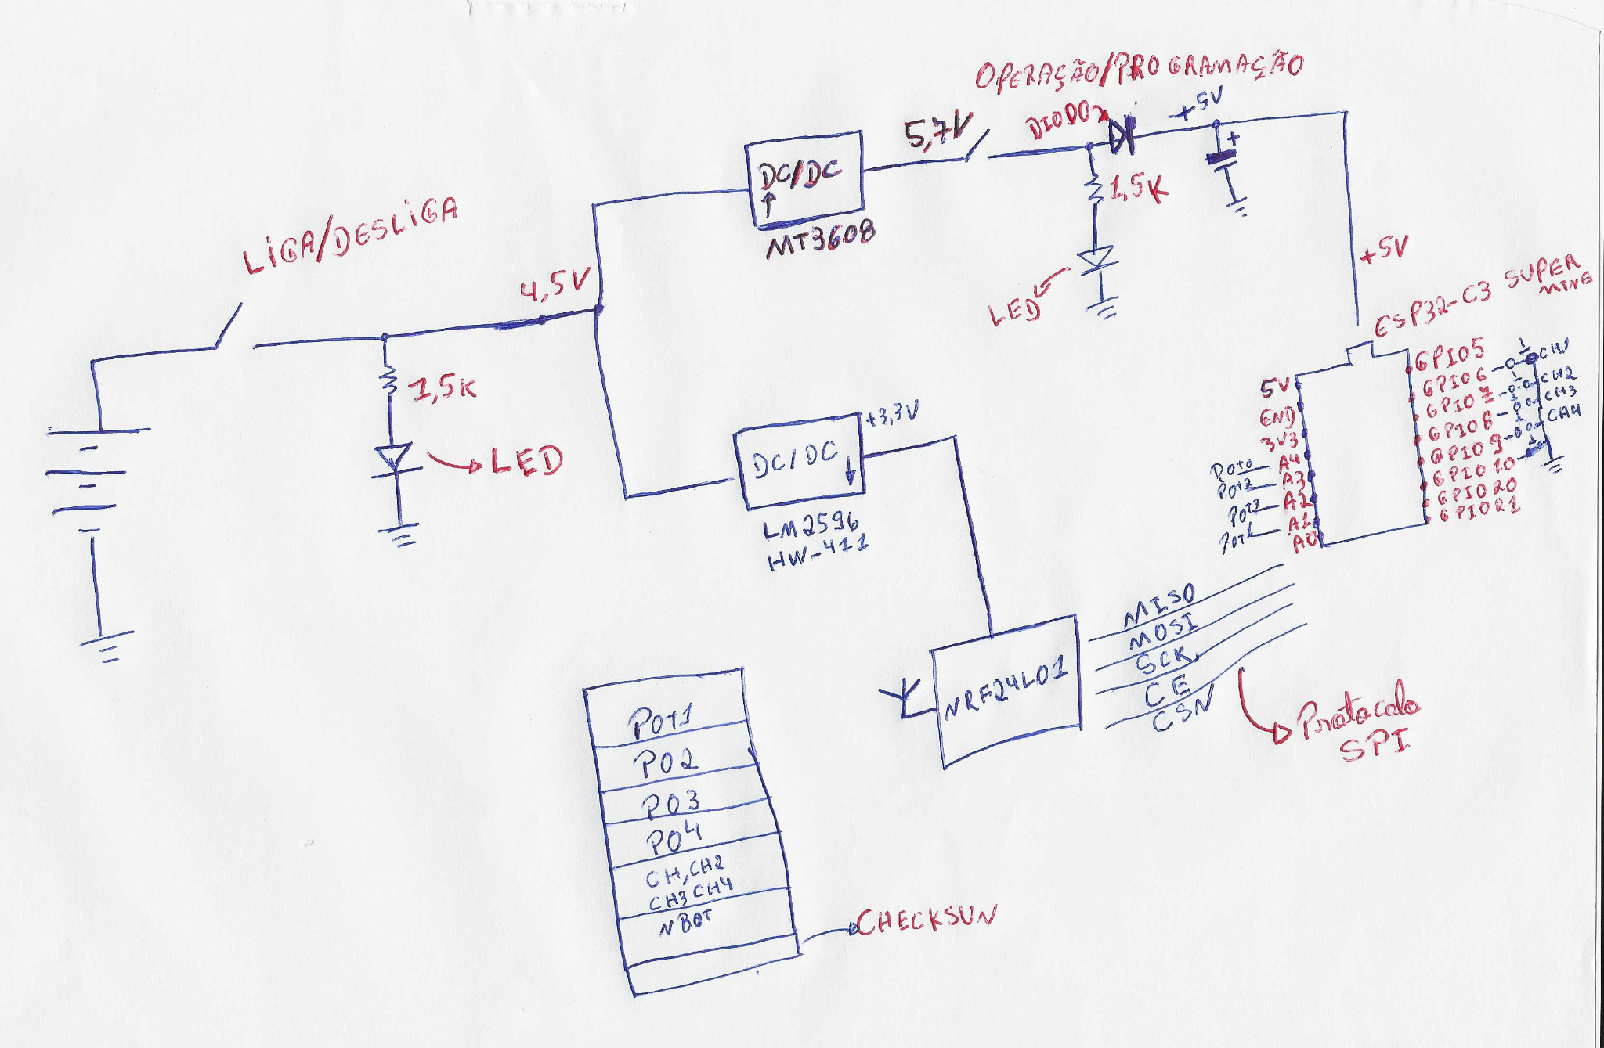
Figure 2 – Turbine Reception System
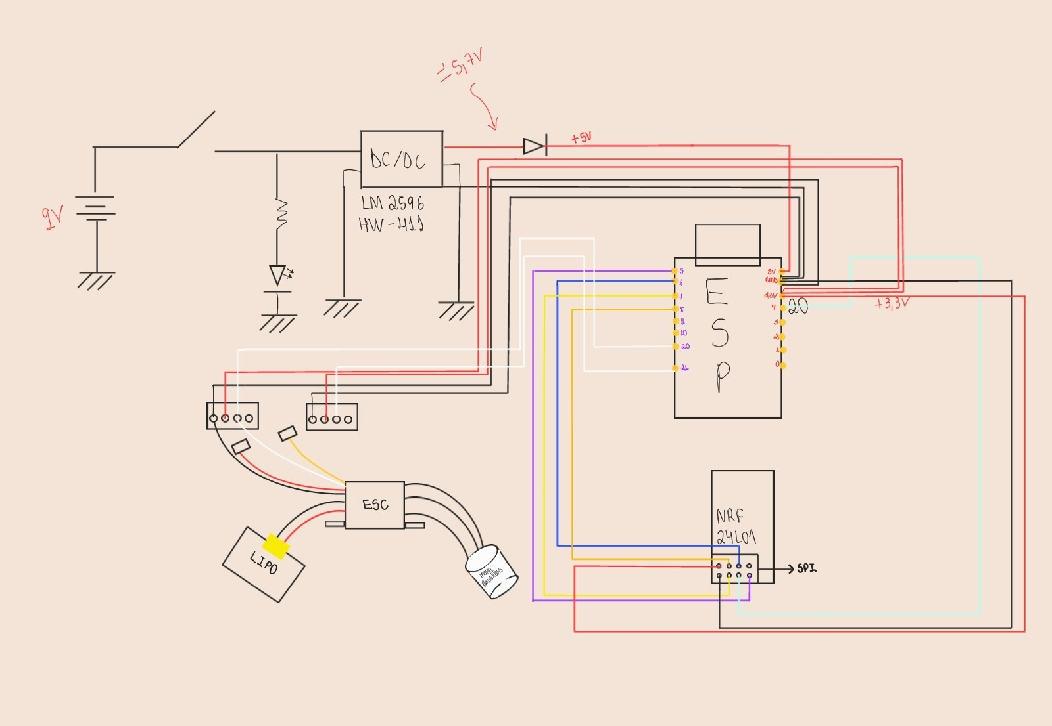
Figure 4 – Turbine Model
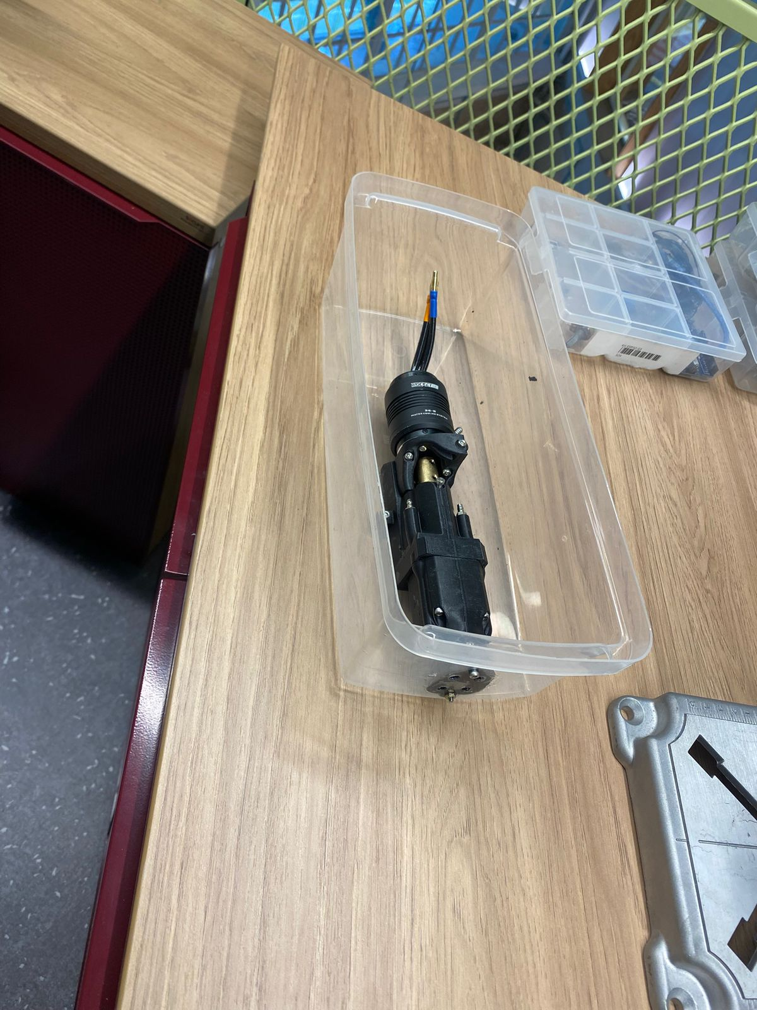
Figure 4 – [Figure 4 Title]................................................................................page]

List of Abbreviations and Acronyms

CRC32 – Cyclic Redundancy Check 32-bit

ESC – Electronic Speed Controller

GPIO – General Purpose Input/Output

LiPo – Lithium Polymer

NRF24L01 – Nordic Radio Frequency 2.4 GHz Module

PWM – Pulse Width Modulation

SPI – Serial Peripheral Interface

Summary (mandatory item – NBR14724, item 4.2.1.13; NBR 6027)

1 Introduction 10
2 Water Turbine 11
2.1 Definition of Market Premises and Hypotheses: 11
2.2 Market Sizing and Analysis: 11
2.3 Competitive Analysis and Differentiators: 12
2.4 Technological Solution 12
2.5 The Business Plan 13
2.6 Validation and Results 15
3 Conclusion 16
References 16
Appendices 17
Annexes 17

Introduction
The maritime and aquatic sector presents significant challenges related to safety and operations in ocean environments. Depth, ocean immensity and adverse conditions such as waves and maritime currents make rescue operations and recreational activities difficult. Nautic.Bot emerges as an innovative technological solution: a remotely controlled underwater turbine that can act as safety equipment or for recreational use in the aquatic/maritime sector. The market opportunity identified lies in the development of more efficient and accessible maritime safety equipment, in addition to the potential recreational market for aquatic activities.

  - Problem Definition and Value Proposition:
  - The central problem lies in the need for maritime safety equipment that is portable, easy to operate and capable of operating in adverse conditions. Nautic.Bot offers a value proposition based on precise remote control, reliable wireless communication, real-time telemetry and compact design that facilitates transport and operation. The solution alleviates customer pain by providing a more efficient and accessible rescue equipment, in addition to offering a recreational alternative for aquatic activities.

  - Objectives of the Work:
  - General: Develop and validate a computational solution for a remotely controlled underwater turbine and develop a business plan for its introduction to the market.

  - Specific: Develop MVP of the turbine with wireless control system; Implement robust communication between transmitter and receiver; Validate technical functionality of the system; Define revenue model and go-to-market strategy; Conduct market validation with potential customers.

  - Justification and Contributions:
  - The market relevance of the solution lies in the growing demand for maritime safety equipment and the potential recreational market. Technologically, the project contributes with the integration of embedded systems, robust wireless communication and brushless motor control. Economically, the solution presents potential for scalability and accessibility compared to similar equipment on the market.

  - Work Structure:
  - This work is organized as follows: Section 2 presents the development of the solution, including definition of market premises, competitive analysis, detailed technological solution, business plan and validation results. Section 3 presents the conclusions and final considerations.

Aquatic Turbine

Definition of Market Assumptions and Hypotheses:

    - Problem Hypothesis
Companies in the maritime sector and aquatic safety organizations face difficulties in carrying out efficient rescue operations due to adverse conditions, lack of portable and easy-to-operate equipment, and real-time data. These organizations are willing to invest in solutions that improve the efficiency and safety of their operations.

    - Solution Hypothesis
The remotely controlled underwater turbine is the best way to solve the problem, offering precise control, real-time telemetry, portability and capacity to operate in adverse conditions. The technological solution based on ESP32-C3 and NRF24L01 communication provides the reliability necessary for critical operations.

    - Value Hypothesis
The revenue model based on equipment sales and possible maintenance services is acceptable to the customer, considering the added value in terms of operational efficiency and safety.

Market Sizing and Analysis:

    - Market Size (TAM, SAM, SOM):
    - TAM (Total Addressable Market): The total addressable market includes all organizations that carry out maritime operations, including aquatic safety companies, rescue organizations, marinas, nautical clubs and the recreational market. According to Business Research Insights (2023), the global maritime salvage services market was estimated at approximately US$ 5.78 billion, with a growth projection to US$ 7.8 billion by 2032. Considering the Brazilian context, which has more than 8,000 km of navigable coastline and approximately 500,000 registered vessels (Brazilian Navy, 2024), in addition to the significant growth of water sports, nautical tourism and river and coastal rescue operations, a Brazilian TAM of approximately R$ 2.5 billion is estimated for the maritime rescue equipment and portable aquatic propulsion market.;
    - SAM (Serviceable Available Market): The market available for services comprises aquatic safety organizations and maritime sector companies that need rescue equipment. Segment focused on professional safety operations. Considering the Brazilian market for rescue and portable aquatic propulsion equipment, a SAM of approximately R$ 450 million is estimated, representing about 18% of TAM, focused on professional aquatic safety organizations, maritime operations companies, marinas and nautical clubs that operate in coastal and river regions.
    - SOM (Serviceable Obtainable Market): The initially obtainable market comprises aquatic safety organizations in coastal regions of Brazil, with potential expansion to the recreational market after initial validation. Based on the business plan's financial projections, which forecast more than 1,200 active turbines by 2032, considering the revenue model with monthly subscription of R$ 150/unit and implementation value of R$ 2,500/unit, a SOM of approximately R$ 2.2 million annually in recurring revenue by 2032 is estimated, representing the initially capturable portion of the Brazilian portable maritime rescue equipment market..

    - Customer Segmentation and Profiling
The target customer profile includes aquatic safety organizations, maritime operations companies in the oil and gas sector, marinas and nautical clubs. The main persona is an aquatic safety manager who seeks efficient, portable and easy-to-operate equipment to improve response capacity in emergency situations.

Competitive Analysis and Differentials:

  - Identification of Direct and Indirect Competitors:

Direct competitors include traditional aquatic rescue equipment and existing underwater propulsion systems. Indirect competitors include alternative maritime safety solutions and recreational aquatic equipment.

  - Competitor Analysis:

Analysis of prices, features, strengths and weaknesses of the main competitors identified in the market. Most existing solutions present limitations in terms of portability, cost or operational complexity.

  - Definition of Competitive Advantage and Differentiating Factor:

Nautic.Bot's competitive advantage lies in the combination of embedded technology (ESP32-C3), robust wireless communication (NRF24L01), compact design and portability. The main differentiating factor is the integration of precise remote control with a real-time telemetry system, offering a complete and accessible solution.

Technological Solution

    - Requirements and Specifications:

Functional Requirements: Remote control system with wireless communication; Brushless motor control via ESC; Data integrity validation via CRC32; Control interface with joysticks and buttons.

Non-Functional Requirements: Minimum communication range of 100 meters; Minimum battery autonomy of 30 minutes; Water resistance and maritime conditions.

User Specifications and Use Cases: The system must allow intuitive control of the turbine through joysticks, with visual feedback and automatic safety mechanisms.

    - Architecture and Technology:

System Architecture: The system consists of two main modules: the transmitter (portable controller) and the receiver (system embedded in the turbine). Communication is established via NRF24L01 radio protocol.

Technologies Used: ESP32-C3 Super Mini as main microcontroller; NRF24L01 module for wireless communication; Arduino libraries for firmware development; ESC for brushless motor control; MT3608 and LM2596 voltage regulators.

    - Development and Implementation (MVP):

Modules and Features Implemented in the MVP: Joystick command transmission system; Data reception and validation system; Brushless motor control via ESC among others.

    - Testing and Technical Evaluation:

Testing Strategies: Unit testing of communication modules; Integration testing between transmitter and receiver; Acceptance testing of the complete system.

The Business Plan

    - Market and Competitor Analysis:

2.5 The Business Plan

Market and Competitor Analysis:

Segmentation and Target Audience (Persona): The main target audience are aquatic safety organizations and maritime sector companies in oil and gas that need efficient and portable rescue equipment and recreational use.

Strengths, Weaknesses, Opportunities and Threats Analysis (SWOT Analysis):

Strengths: Modern and robust technology; Compact and portable design; Reliable wireless communication.

Weaknesses: Dependence on imported electronic components; Need for validation in real use conditions; Global competition as it is more of a hardware business than software and does not have a "local" component of defensability;

Opportunities: Growth of the maritime safety market; Potential recreational market; Expansion to international markets.

Threats: Competition from established solutions; Maritime regulations; Currency variations affecting costs.

2.5.1 The Business Plan

Market and Competitor Analysis:

Segmentation and Target Audience (Persona): The segmentation strategy initially prioritizes the B2B (Business-to-Business) market, focusing on three main segments, in order of priority: (1) Oil & Gas Sector: companies that carry out offshore operations and need safety and rescue equipment for platforms and support vessels, representing high contract value and longer sales cycle; (2) Aquatic Safety Organizations: professional lifeguards, coastal and river rescue organizations, which need portable equipment for rescue operations; (3) Naval and Maritime Operations: port logistics companies, dredging operations and maintenance of aquatic structures. The main persona is an aquatic safety manager or maritime operations coordinator who seeks efficient, portable and easy-to-operate equipment, with local technical support and predictable revenue model, to improve response capacity in emergency situations. The recreational market will be explored with a solution more appropriate for the segment.

Strengths, Weaknesses, Opportunities and Threats Analysis (SWOT Analysis):

Strengths: Modern and robust technology; Compact and portable design; Reliable wireless communication.

Weaknesses: Dependence on imported electronic components; Need for validation in real use conditions; High entry cost that may limit expansion in the short term; Global hardware competition without local defensability component; Scalability challenges in production and distribution in Brazil.

Opportunities: Growth of the maritime safety market; Potential recreational market; Expansion to international markets; Opportunity for service revenue in sectors such as Oil & Gas and Ships; Being the only local Brazilian solution brings cost and support advantages; B2B sales with higher contract value and stability.

Threats: Competition from established solutions (Seabob, Yamaha, Sublue); Maritime regulations and need for certifications; Currency variations affecting production costs; Difficulty charging monthly subscription in some segments; Logistical bottlenecks to scale distribution in Brazil.

Competitor Analysis and Product Differentiators: The detailed analysis of the main competitors reveals that Nautic.Bot differentiates itself through: (1) Technical differentiators: modern embedded technology (ESP32-C3), robust wireless communication (NRF24L01) with 100-meter range, data integrity validation system (CRC32), automatic failsafe mechanism, and real-time telemetry capability; (2) Value differentiators: OPEX revenue model that eliminates entry barriers, national technical support with fast response, preventive and corrective maintenance included, firmware updates and hardware modernization, customization for specific customer needs, and complete Brazilian regulatory compliance; (3) Competitive differentiators: only local Brazilian solution, complete hardware-software-service integration, product lifecycle managed by the company, and business model that guarantees recurring revenue and customer loyalty. These differentiators position Nautic.Bot as a superior solution for customers who value local support, financial predictability and reduction of total cost of ownership.

Business Model (Business Model Canvas - BMC):

Value Proposition: Portable and rechargeable aquatic turbine with wireless remote control, offered through a monthly subscription model (OPEX) that includes equipment, operation, maintenance, technical support and updates. Accessible, sustainable and technically robust solution, with national support and Brazilian regulatory compliance.

Customer Segments: (1) Oil & Gas Sector (initial priority) - offshore companies and platforms; (2) Aquatic Safety Organizations - lifeguards, coastal and river rescue; (3) Naval and Maritime Operations - port logistics, dredging, aquatic maintenance; (4) Recreational Market (phase 2) - resorts, marinas, nautical clubs.

Channels: Direct B2B sales through specialized commercial team, strategic partnerships with maritime sector distributors, presence at sector fairs (Rio Boat Show, SP Boat Show), digital marketing with nautical sector influencers, and practical demonstrations at strategic locations.

Customer Relationships: Specialized national technical support, preventive and corrective maintenance included, regular firmware and hardware updates, solution customization, and loyalty programs with progressive discounts for multiple units.

Revenue Streams: (1) Recurring monthly subscription: R$ 150/unit (covers support, maintenance, updates); (2) Implementation value: R$ 2,500/unit (activation, customization, logistics, integration); (3) Additional services: operator training, aquatic safety consulting, integration with existing systems; (4) Service revenue for specific sectors: Oil & Gas and Ships (opportunity identified in the board's feedback).

Key Resources: R&D team in São Paulo, manufacturing partnerships in China, technical knowledge in embedded systems and wireless communication, national technical support infrastructure, and B2B customer relationships.

Key Activities: Product development and continuous improvement, manufacturing and assembly (China), logistics and distribution, technical support and maintenance, B2B sales and customer relationship, and regulatory certifications.

Key Partners: Chinese manufacturers for scale production, electronic component suppliers, maritime sector distributors, aquatic safety organizations for validation, regulatory bodies (INMETRO, Brazilian Navy), and strategic partners in Oil & Gas and naval operations.

Cost Structure: Production costs (COGS): electronic components, assembly, packaging; Operating costs: taxes (15% Simples Nacional), maintenance (10% of revenue), general and administrative expenses (R$ 120 thousand annually), logistics and distribution, technical support, and marketing and sales.

    - Marketing and Sales Strategy:

Go-to-Market Strategy: The market entry strategy prioritizes the B2B segment, starting with the Oil & Gas sector due to high contract value and need for robust safety solutions. The approach includes: (1) Identification and approach of anchor customers in the Oil & Gas sector and naval operations; (2) Development of specific use cases for each segment, demonstrating capacity to drag loads of up to 150kg; (3) Strategic partnerships with public rescue agencies and maritime operations companies; (4) Gradual expansion to aquatic safety organizations in coastal regions; (5) Exploration of the recreational market in a later phase, after B2B consolidation. The strategy recognizes that the B2B sales cycle is longer, but offers greater stability and contract value.

Customer Acquisition and Retention Strategies: (1) Acquisition: strategic partnerships with aquatic safety organizations and maritime sector companies; participation in sector fairs (Rio Boat Show, SP Boat Show); online campaigns with nautical sector influencers; practical product demonstrations with capacity to drag heavy loads; direct approach to potential customers in Oil & Gas and naval operations; presence at corporate sector events; (2) Retention: monthly subscription model that guarantees recurring revenue; specialized technical support and fast response; included preventive maintenance reducing customer costs; regular firmware updates and hardware modernization; loyalty programs with progressive discounts; close relationship through national technical team; (3) Expansion: identification of service revenue opportunities in sectors such as Oil & Gas and Ships, according to board feedback, including consulting, training and integration services with existing systems.

    - Financial Projection and Feasibility:

Revenue Model and Pricing Structure: Nautic.Bot adopts a model entirely based on OPEX, where the customer pays for the monthly use of the equipment, without the need for purchase or initial investment. The model includes: (1) Monthly subscription: R$ 150/unit – covers technical support, preventive and corrective maintenance, hardware modernization and software updates; (2) Implementation value: R$ 2,500/unit – initial cost for turbine activation and customization, including logistics and system integration; (3) Additional revenues: consulting services, training, integration with existing systems, and service revenues for specific sectors (Oil & Gas, Ships). The final package value considers profit margin with turbine operation, ensuring financial predictability and customer loyalty.

Projected Expenses, Break-Even Point and Viability Indicators: Based on financial projections for the period 2028-2032, the cost structure includes: taxes of 15% (Simples Nacional), maintenance of 10% of revenue, and general and administrative expenses of R$ 120 thousand annually. The business presents a gradual maturation curve, with negative EBITDA in the first two years (2028-2029) due to initial implementation costs and production scaling. From 2030 onwards, the model becomes profitable, reaching EBITDA margins of 44% in 2031 and 65.8% in 2032, sustained by the increase in recurring contracts and dilution of fixed costs. The break-even point is projected to occur between 2029 and 2030. The payback (time necessary for the accumulated cash flow to equal the initially invested capital) estimated is approximately three years after the start of scale operation. Projections indicate more than 1,200 active turbines by 2032, with estimated annual recurring revenue of R$ 2.2 million and growing EBITDA above R$ 1.4 million in 2032.

Definition of Initial Investment Requirement: The necessary initial investment comprises: (1) Production: development of molds, tools and production setup in China (estimate of R$ 200-300 thousand); (2) Marketing and sales: structuring of commercial team, participation in fairs, digital campaigns (estimate of R$ 100-150 thousand); (3) Initial operations: technical support infrastructure setup, regulatory certifications (INMETRO, Brazilian Navy), use case development and validation with anchor customers (estimate of R$ 150-200 thousand); (4) Working capital: initial inventory, logistics and operation until reaching break-even point (estimate of R$ 200-300 thousand). Total estimated: R$ 650-950 thousand, considering that this financial projection is what Nautic.Bot intends to achieve from the first anchor customer and initial contributions or investments. All these values are subject to changes according to market conditions and negotiations with investors.

Validation and Results

    - Validation Methodology:

The validation methodology included multiple approaches to test business hypotheses and MVP acceptance: (1) Structured interviews with potential customers in aquatic safety organizations, maritime sector companies and safety managers in Oil & Gas, totaling more than 15 qualitative interviews; (2) Practical product demonstrations in controlled environments, including tests of capacity to drag loads and operation in aquatic conditions; (3) Structured feedback collection through questionnaires on needs, pain points, willingness to pay and business model preferences; (4) Comparative analysis with existing solutions in the market, identifying gaps and opportunities; (5) Technical validation of the MVP through functionality, robustness and system security tests.

    - Market Validation Results:

Market validation results revealed: (1) Customer feedback: strong interest in the subscription model (OPEX) as an alternative to the high acquisition cost of premium equipment, appreciation of local technical support, and need to demonstrate capacity to drag heavy loads (up to 150kg) for rescue applications; (2) Engagement metrics: 80% of interviewees demonstrated interest in learning more about the solution after demonstration, 65% indicated need for similar equipment in their operations, and 45% expressed willingness to test the product in a real environment; (3) Conversion rate: B2B sales cycle identified as longer (3-6 months), but with higher contract value and stability; (4) Interest indicators: Oil & Gas sector identified as high-value opportunity, recreational market validated as viable in second phase, and need to focus on specific segment initially for adequate product development. Based on feedback, the strategy was adjusted to prioritize B2B market (Oil & Gas, aquatic safety) before the recreational market, and explore additional service revenues.

    - Key Performance Indicators (KPIs):

The main projected performance metrics include: (1) CAC (Customer Acquisition Cost): estimated at R$ 2,000-3,000 per B2B customer, considering longer sales cycle and need for demonstrations and relationship; (2) LTV (Lifetime Value - Customer Lifetime Value): estimated at R$ 18,000-36,000 per customer, considering monthly subscription of R$ 150/unit, multiple units per customer (average of 2-4 units), and retention time of 3-5 years; (3) Churn rate: target of less than 10% annually, guaranteed through quality technical support, preventive maintenance and subscription model that reduces exit barriers; (4) EBITDA margin: growth projection from -42% in 2028 to 65.8% in 2032, according to financial data; (5) Number of active turbines: projection of more than 1,200 units by 2032; (6) Monthly recurring revenue (MRR): projected growth from R$ 18,000 in 2028 to R$ 180,000 in 2032.

    - Risks and Mitigation Plan:
Identification of critical business risks and mitigation actions: (1) Financial risks: currency variations affecting production costs in China - mitigation through long-term contracts with suppliers, currency hedging, and progressive nationalization of the supply chain; high entry cost limiting expansion - mitigation through OPEX model that reduces barriers, seeking initial investment and anchor customers; (2) Technological risks: dependence on imported electronic components - mitigation through supplier diversification, safety stock, and development of local alternatives; scalability challenges in production and distribution - mitigation through strategic manufacturing partnerships, outsourced logistics, and capacity planning; (3) Legal risks: maritime regulations and certifications - mitigation through proactive compliance with INMETRO and Brazilian Navy, specialized consulting, and regulatory monitoring; (4) Competitive risks: global hardware competition without local defensability component - mitigation through focus on local technical support, subscription model that creates exit barriers, hardware-software-service integration, and close customer relationship; low-cost Chinese products - mitigation through differentiation in quality, support, regulatory compliance and business model; (5) Operational risks: difficulty charging monthly subscription - mitigation through clear contracts, continuous value demonstration, and model that includes tangible services (maintenance, updates); bottlenecks to scale and distribute in Brazil - mitigation through logistics partnerships, structuring of technical support network, and planning of gradual expansion by region.

Conclusion

The objectives established in this work were achieved through the development of a functional MVP of the Nautic.Bot turbine, with a robust wireless control system and successful technical validation. The solution demonstrated technical viability and market potential, establishing a solid foundation for future evolutions. The commitment and persistence demonstrated throughout the development contributed to a consistent evolution of the work, resulting in a product ready for use with relevant features for the final use.

Future projections include: (1) Product refinement based on validation feedback, including demonstration of capacity to drag loads of up to 150kg; (2) Initial focus on the B2B market, prioritizing the Oil & Gas sector and aquatic safety organizations, before expansion to the recreational market; (3) Development of additional features such as advanced telemetry and integration with monitoring systems; (4) Exploration of service revenues in specific sectors such as Oil & Gas and Ships; (5) Search for strategic partnerships for scalability, including anchor customers and investors; (6) Mapping and resolution of the main bottlenecks to scale and distribute the product in Brazil; (7) Consideration of Chinese products as competition in the leisure use segment and development of differentiation strategies.

Final considerations highlight: (1) The importance of integration between technical development and market validation, recognizing that adjustments to the business model are necessary to explore more scalable paths; (2) The need for continuous iteration based on real feedback, especially regarding the clear definition of the initial segment of operation and competitive differentiators; (3) The potential of the solution to contribute to maritime safety and recreational aquatic activities, positioning Nautic.Bot as the only local Brazilian solution with cost and national technical support advantages; (4) The scalability challenges and high entry cost, which require specific mitigation strategies and seeking initial investment; (5) The importance of thinking about multiple monetization sources, including services beyond the subscription model, to increase the viability and sustainability of the business.

References

BUSINESS RESEARCH INSIGHTS. Marine Salvage Services Market. 2023. Available at: https://www.businessresearchinsights.com/pt/market-reports/marine-salvage-services-market-116079. Accessed on: Oct. 27, 2025.

BRAZILIAN NAVY. Nautical Statistics. 2024. Available at: https://www.marinha.mil.br/. Accessed on: Oct. 27, 2025.

RIO BOAT SHOW. Rio Boat Show 2026, Connecting Sea and Opportunities. 2026. Available at: https://rioboatshow.com.br/. Accessed on: Oct. 27, 2025.

SÃO PAULO BOAT SHOW. São Paulo Boat Show: Where art breaks concrete and nautical style comes to life. 2025. Available at: https://saopauloboatshow.com.br/. Accessed on: Oct. 27, 2025.

